Standish Medical Practice New Year Newsletter
  - Wishing all our patients a happy new year
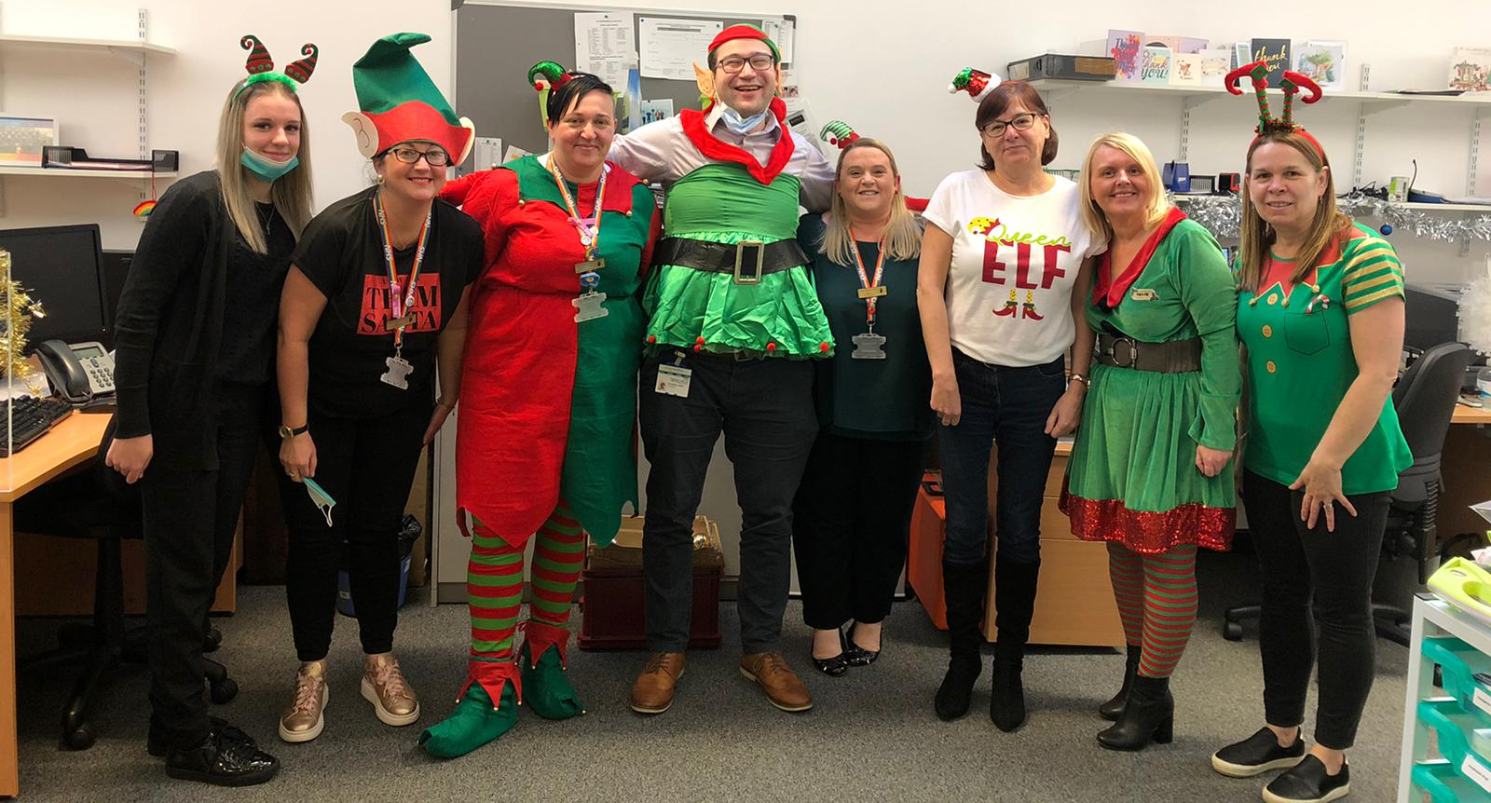
HAPPY NEW YEAR  We hope that you all had a peaceful and safe Christmas and that 2022 is a healthy year for you all.  Thank you for your patience with us during difficult recent weeks for us when we have been impacted on by staff sickness and isolation. Our statistics show that we have continued to provide the same levels of access despite shortages and have used your feedback to alter our systems.  We have some plans in place to improve access further over the busy winter months and continue to be grateful for all your feedback to assist us. | adjustments to amgp  We altered the way we use AskmyGP in October to try and improve our communication with you and to allow patients to prebook appointments as well as received urgent care when needed. We have introduced a system where all queries are triaged at source by a GP and patients are contacted quickly to confirm appointment details. This has reduced waiting times and also means patients can plan their day better without waiting for us to call for several hours or even a few days. Communicating with patients more quickly seems to have improved overall patient satisfaction and has reduced the need for patients to chase up their appointments. | PHONE SYSTEM  After multiple complaints about our phone lines and the difficulties people were having in getting through when they needed to we have been in talks with the CCG who provide our phone system. We are currently altering the system so that calls can be streamlined to the relevant person, e.g. a Receptionist, a Secretary, an Administrator or a Pharmacist. We have also installed software to allow us to monitor call demand in real time and identify more quickly where patients appear to be struggling to get through. We hope the new system will be live by the end of January and improve this service for you all.
OUR CHRISTMAS DISPLAYS

We recognise that the last two years have been incredibly difficult for many of our patients.

In particular, we are aware that those who have supported a loved one at the End of Life, or those unexpectedly bereaved during the pandemic have likely struggled more due to the social isolation and loss of their usual support network, the visiting restrictions to hospitals and care homes, and the inability to give some special individuals the send off they would have preferred to.

We chose to remember each life lost this year by displaying a single crocheted snowflake for each patient who has been lost this year.

We hope that the village found this a beautiful tribute to those missed by our community this Christmas.
Our Children’s Christmas Tree  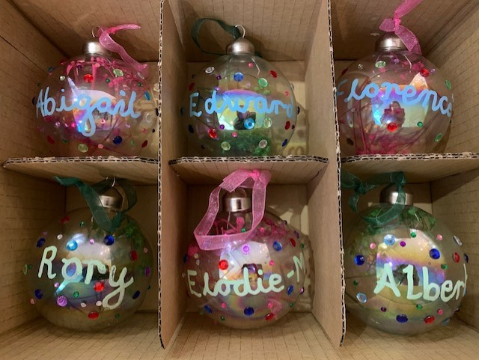  As a celebration of the new life in Standish we also wanted to create a Christmas display to celebrate each baby born into our patient community this year.  We created an individual bauble for each and every child to be born in 2021.  It has been magical to see little ones attending with their parents and siblings to look for their bauble and we look forward to watching them grow.  We have done this in conjunction with our collection for The Brick - | 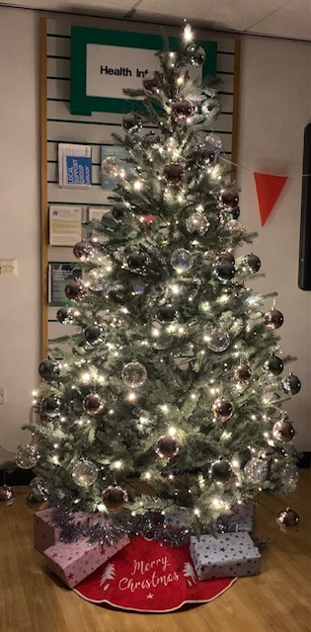
DROP IN TO CHECK YOUR OWN MEASUREMENTS  Many patients have a long-term condition or take regular medication that needs annual monitoring. We understand that attending for regular check ups can be a nuisance when you are feeling well and busy with your own work and other activities.  With this in mind, we have allocated a side room next to our front desk in the main Reception area to be used by patients preferring to drop in to check their own blood pressure and height and weight. Annual urine dips and protein checks can also be left with our Reception staff and blood test forms printed for annual bloods.  We have found patients are getting more familiar with this facility and are finding it convenient and stress free. No appointment is needed and the room is private and secure.  We hope that patients requiring contraceptive pill checks will also be able to use this service soon as we are designing a ‘pill check’ questionnaire which they can leave for a clinician to review with their relevant measurements.  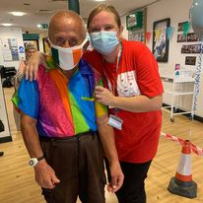 | 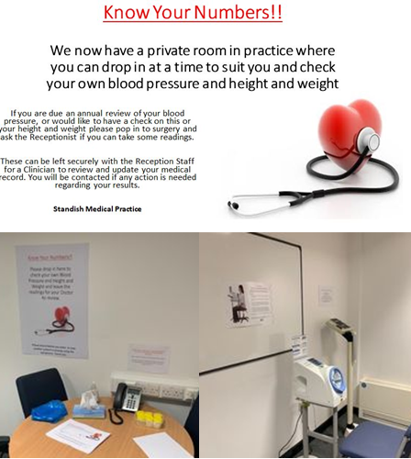  FLU AND COVID CAMPAIGNS 2021  We had worked incredibly hard on the Flu Vaccination campaign this Autumn as the eligible population was bigger than ever before and the demand very high in the light of the pandemic. We had a couple of really successful Saturday clinics at the beginning of the Autumn to make sure we vaccinated the most vulnerable of our patients as early as possible. We are so pleased to have been able to offer this service in house without the need for patients to travel to Robin Park. To date, we have vaccinated 3045 patients. We still have around 50 vaccines left if anyone would like to have theirs – please contact our Reception for an appointment.  We have also visited 160 vulnerable people at home and administered their COVID boosters for them. It has been our absolute privilege to be able to help fight the pandemic and steer us all back to safer and happier times.  We wanted to share this lovely photograph of Eric Whitter with our Vicky at the first flu clinic. What a lovely chap and a fabulous shirt!! All the smiles and the kind words from patients like him made our day.

COVID VACCINATIONS
Anyone wanting to book any of their Covid vaccinations can still do so by phoning the GP Alliance on 01942 807 780. Please do not call unless you are eligible to do so. Find out more online at https://www.nhs.uk/conditions/coronavirus-covid-19/coronavirus-vaccination/coronavirus-booster-vaccine/

PATIENT PARTICIPATION GROUP
We have postponed our regular face to face meetings with our PPG since the lockdown began but are now keen to restart these. We tend to every eight weeks at the Practice for an hour or two to discuss the service we are providing and any feedback or suggestions from patients. This is our way of working with you to optimize the care we provide. We plan to restart these meetings on a Thursday evening from the end of January. Start time is generally 6.30pm. If you would be keen to be considered to join the PPG please forward your interest FAO Mrs Jayne Johnson, Practice Manager at gp-p92014@nhs.net.

PRACTICE TRAINEES
In December we said goodbye to two of our Foundation doctors, Dr Matthew Fieldhouse and Dr Grace Allport, as they move on to the next placement in their training rotation. We wish them all the best and, in the meantime, have welcomed two more Foundation doctors in their place, Dr Wahid Ghaffari and Dr Khui Wee, both of whom have already proven hugely popular with patients and staff. They will be working here until April 2022.

THE PRE-SCHOOLER SURGERY EXPERIENCE
We would like to hear patient opinion about the pre-schooler experience when attending the surgery for appointments. We recognise that medical settings can be scary and intimidating environments for little ones, and would like to make sure we are doing all we can to make their visit to the surgery as comfortable and stress free as possible for both them and those attending with them. Please could you consider taking a few minutes to fill in the survey by clicking on the link below. All responses are completely anonymised and will be reviewed by the clinical staff here to try and improve the service we are currently providing. Thanks so much to those of you who take the time to give us this feedback
https://docs.google.com/.../1FAIpQLSeBAhrn1rT.../viewform...

HOT CLINICS
Hot clinics are still running within the Wigan borough for patients with potential COVID symptoms. These include cough and fever which obviously are very common at this time of the year and often due to other causes. Anyone needing advice about these symptoms will get it from us if they request it, but any patient felt to require physical examination will need to be referred by us to one of the ‘Hot Clinics’ where they will be assessed further by another GP and if needed offered an appointment at the site or a home visit. We appreciate that many patients find having to travel further to be seen a frustration and we share this with you – Sadly this is how we have been advised to continue working currently to optimize safety for other patients and the practice staff.

FACE MASKS IN SURGERY
Currently we still ask all patients attending the surgery to wear a face covering. This is in line with other NHS providers and is important to protect other vulnerable patients who may need to attend the surgery as well as the staff who are dealing with large numbers of patients face to face each day.

ANNUAL REVIEWS
As of 1st April 2021, the Practice have started the process of moving patient’s annual review (e.g. for Diabetes, Heart Disease, Asthma etc) to the birth month of each patient. This may mean you are called for your review a little earlier or later than you were expecting. Please do not worry about this. You medication is still being monitored and any patient requiring an appointment as a priority outside of these arrangements will still be called for. We are offering face to face appointments to those who need or prefer this but telephone reviews can also be offered for those able to send in any physical measurements (e.g. blood pressure, pulse, height and weight) from home. Additionally, we are asking many Asthma and COPD patients to complete a questionnaire via text message to assess control. This may mean that you are not required to attend for a face to face review so please make sure you do your best to answer the questionnaires for us where possible.

ELECTRONIC PRESCRIPTIONS
If you have not already done so, we recommend patients sign up for this service. If you contact your nominated pharmacy they will add you to the system so that whenever you request a prescription it will be sent electronically to the pharmacy for you to collect, meaning there is no need for you to attend the surgery to collect a paper copy first. You can also ask your pharmacists to deliver to your home if this is needed.
If you do not already have access to online prescription ordering and would like to use this service then please telephone the surgery. We will require your email address. The receptionists will then be able to create an account for you and email the log in details and registration processes to you.
You can also request to act as proxy for relatives and dependents that you care for using patient access. Please ask the receptionists for further details.

CAR PARK
As the surgery continues to offer more face to face appointments the car park is becoming increasingly busy. Please be aware that the limited number of on site spaces are reserved for the disabled or parents with small children and we would ask all other patients to find somewhere else to park. The throughfall of traffic is a risk to pedestrians and vehicles on site. We have recently risen this issue with our landlords again having had no support previously to improve safety and access. We apologise that we cannot offer parking for all.

OUR PRACTICE TEAM

GP Partners Dr Nadia Ghalayini, Dr Andrew Cross, Dr Sadia Alam

Salaried GPs Dr Rebecca Lund, Dr Mark Ngu, Dr Greta Gregory, Dr Rebecca Atherton

Locum GP Dr Edel Anthony

Advanced Clinical Practitioner Victoria Browne (Nurse Manager)

Advanced Nurse Practitioner Tracy Pardoe

Practice Nurses Nicola Myers, Elaine Peet, Trudie Abbott

Health Care Assistant Elizabeth Freeman

Pharmacist Lyndsey Lonsdale, Krupesh Patel

Practice Management Jayne Johnson (Practice Manager)
Joanne Clark (Deputy Practice Manager)
Ann O’Brien (Accounting and Finance Manager)

Secretaries Maureen, Michelle, Carole

Administrative Staff Susan, Toni, Julie, Charlotte

Reception Staff Amanda, Julie, Kimberley, Lesley, Sharon, Diane, Sara, Rachael, Mollie

Prescription Clark Lesley

PCN Pharmacist Jennifer

PCN Pharmacy Tech Joanne

PCN Physiotherapists Helena, Nathan

PRACTICE CHARITY 2021
As you know we held some in house activities this year to raise money for Dementia UK and the Alzheimer’s Society. We have completed some final events including finally awarding our sunflower cup to the tallest and biggest sun flowers as well as a pumpkin carving contest, and some Christmas dress up days, We have raised £500 for these charities which we are immensely proud of given all our fundraising has been practice based without much opportunity to arrange big events due to the pandemic. Thanks to all the staff contributions and any additional patients wishing to do so our collection boxes will remain at our Front Desk until our new charity is selected. Thanks also to all donations to The Brick – The collection point will remain in place so please feel free to donate what you can.
